**Ritesh**

BI/DW/ETL/Database Engineer Lead

email: [rrsql24@gmail.com](mailto:rrsql24@gmail.com) | Phone: +1 469 598 1471

##### SUMMARY

* **Certified Professional Technology Specialist** with **15+** years of extensive hands-on experience in Information Technology industry with a strong background in analysis, design and development of business intelligence, data modeling and data warehouse applications, data and schema migration/ integrations, analytics, and reporting systems.
* BI and analytics expert with solid hand-on experience in databases, data migration, and data modeling for enterprise data warehouse and data marts, master data management, data quality, ETL and reporting solutions.
* Vast experience in application development and support in Finance/ Banking domain and agile development model.
* Highly adept on **MS SQL Server and BI stack (SSIS, SSRS), Talend Data Integration and administration, Tableau Reporting, PostgreSQL, C#.NET, VB.NET and Cloud platform Azure, AWS.**
* Expertise in data warehousing concepts in OLTP/OLAP system analysis and developing database schemas such as Star Schema and Snowflake Schema for relational and dimensional modeling
* Good experience on data modeling tools for logical and physical data modeling.
* Good knowledge of using various **SQL Server** tools such as **SQL Profiler**, execution plan, performance monitor index tuning wizard and tuning query **performance optimization**.
* In-depth knowledge and understanding of and experience with system architectures, coding protocols and standards, development methodologies, custom interfaces, connectors, and agents as well as project execution methodologies and implementation procedures.
* Interact with business users to analyze the business process and requirements and transforming requirements into technical specifications, documenting, and rolling out the deliverables.
* Possess good organizational skills with ability to work in a fast-paced environment, meet deadlines, good team player and can work independently.
* Strong Communication & Management skills with Excellent Role-playing capabilities.
* Involved in data & database migrations. Data transfers using ETL tools like SSIS and Talend.
* Expertise in Performance tuning, Optimization, Data integrity and Statistics by using Profilers and Database tuning wizard.
* Experience in solving Real Time issues with Index fragmentation, DBCC checks, Query Tuning, Error, and Event Handling.
* Excellent T-SQL Developer skills in **Stored Procedures, functions, Views, Triggers, Cursors** using **SQL Server** with **T-SQL**
* Handson experience on **Snowflake**: Snow SQL, Snow Pipe, Tasks, Streams, Time Travel, Zero-copy cloning, Optimizer, Metadata Manager, data sharing, and Stored Procedures
* Design, develop, and maintain **Amazon Redshift** databases to support data storage and analytics requirements. Create and manage database schemas, tables, views, and indexes in Redshift.
* Experienced in SDLC life cycle for Design, Development and Staging phases of the projects with support of Dataflow, Process Models, E-R Diagrams.
* Expertise in developing reports using SQL Server Reporting Services, tableau, and Power BI.
* Designed and developed data models for the data warehouse using star and snowflake schema.
* Used Talend, SSIS to create ETL jobs to validate, extract, transform and load data to data warehouse and data marts.
* Keen analyst and team player with thorough understanding of all aspects of the SDLC from understanding client requirements through direct client interaction, translating them into technical specifications and driving their execution.

##### SKILLS

* **Primary Skills:**
* **Databases**: MS SQL Server, PostgreSQL, Oracle, Amazon Redshift, Snowflake, MySQL
* **ETL**: SSIS, Talend Data Integration, Python, AZURE Data Factory (ADF)
* **Reporting Tools**: Tableau, SSRS, Power BI
* **Scheduling Tools:** AutoSys, Talend Administration Centre (TAC), SQL Agent
* **Additional Skills:**
* **Scripting** : C#, Java Scripts, Python
* **Data Tech:** Hive, Pig, Sqoop
* **Operating Systems**: MS Windows, UNIX
* **Others**: AWS S3, JIRA, Confluence, GitHub, TFS, SVN, Bitbucket
* **Domains:**
* Wealth Management
* Banking (Credit Risk), Finance
* Mobile Insurance
* Manufacturing

##### EDUCATIONAL QUALIFICATIONS

* Bachelor of Engineering (Information Technology) from Rajiv Gandhi Technical University(RGPV), Bhopal, Madhya Pradesh, India.

##### CERTIFICATIONS

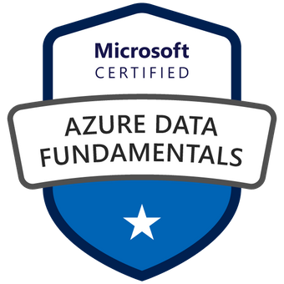 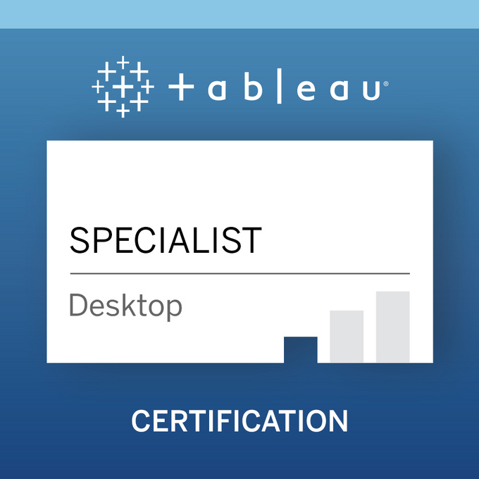

* AWS Certified Solutions Architect - Associate
* Microsoft Certified: Azure Fundamentals
* Microsoft Certified: Azure Data Fundamentals
* Certified Tableau Desktop Specialist

##### PROJECT EXPERIENCE

**Client: Morgan Stanley, Charlotte, NC 07/2021 – till date**

**Role: Sr. Technology Specialist (Data Services)**

**Project: Trade Correction**

**Responsibilities:**

* Design, developed and maintained efficient ETL processes using SQL Server Integration Services (SSIS) to extract, transform, and load data from different sources into data warehouses.
* Extensive experience in writing complex SQL queries using Joins, Stored Procedures, Views, user defined functions, common table expressions, pivot and aggregate functions.
* Design and implement database structures and relationships based on business requirements. Normalize or denormalize database schemas to optimize data storage and retrieval. Worked on different levels of ETL Loads like Extract Data from Source System to Staging and then from Staging to load data into Production Data Base Tables.
* Optimize SQL queries for performance and efficiency. Analyze query execution plans and identify opportunities for optimization.
* Support reporting and analysis initiatives by providing access to accurate and timely data. Collaborate with business users to understand reporting requirements and develop custom reports.
* Build pipelines in SSIS to provide curated data in SQL Server, and Snowflake to empower our business users to do data discovery and analytical reporting using Power BI and other data science tools.
* Identify and address performance bottlenecks in SQL databases. Tune database configurations, indexes, and query execution plans for optimal performance.
* Monitor and analyze SSIS package performance metrics to identify bottlenecks and optimize resource usage.
* Extensively worked on designing reports using SQL Server Reporting Services (SSRS). Developed the SSRS reports like Tabular, Matrix, Charts, Gauge and List.
* Developed SSTS reports such as drill down reports, dashboard, parameterized reports, linked reports, sub reports to populate data warehouse and produce regularly scheduled reporting on internal portal.
* Develop custom SSIS components and scripts using scripting languages such as C# to extend SSIS functionality.
* Onshore offshore coordination
* Prepare the release and deployment plan.
* Production support and incidence management
* Defect triage and root cause analysis.

**Technologies**: Azure SQL Database, TSQL, SSIS, SSRS, C#, ADF, Teradata, HIVE, Tableau, Python, PowerShell.

**Client: Wells Fargo, Charlotte, NC 10/2018 – 06/2021**

**Role: Sr. Technology Specialist**

**Project: Compliance Reporting & Counter Party Risk System (CoRS)**

**Responsibilities:**

* Designed, developed, and scheduled several automated SSIS packages to load data into Datawarehouse
* Wrote C# code using script task in SSIS packages to build ETL process.
* Reported on progress of data conversions and advocate for specific resolution to unique issues in all internal meetings with Implementation personnel
* Primarily involved in Data Migration using SQL, SQL Azure, Azure Storage, and Azure Data Factory, SSIS, PowerShell.
* Implemented various data integration solutions in production environment involving various sources such as SQL Server, CSV flat file, excel, and text files using SQL Server Integration Services
* Used SQL Server database development concepts such as common table expressions, nested sub queries, user defined functions, indexed views, and aggregate functions
* Collaborated with offshore team to designed and build a reporting Database for BI reports
* Perform backup of Prod DB and restore to Dev and QA environments.
* Developed reports with SSRS such as drill down reports, dashboard, parameterized reports, linked reports, sub reports to populate data warehouse and produce regularly scheduled reporting on internal portal
* Responsible for defining source to target data mapping, ETL jobs, database Views and complex T-SQL queries/procedures for testing and data validation
* Improved performance optimization and tuning methodologies for existing Stored Procedures
* Designed, developed, and scheduled several automated SSIS packages using Sql Server agent based on business requirements such as RAPS return files, CMS files to vendors
* Deployed several SSIS packages from development to production environment.
* Collaborated with business users and developed SSRS and PowerBI reports.
* Developed and deployed several reports using SSRS and crystal reports such as parameterized reports, linked reports, sub reports for various departments
* Enforce the data lineage via ETL pipelines in our target tables and other downstream data ingestion layers.
* Used TALEND and SSIS for ETL - Extraction Transformation Loading, Operations Data Store concepts, data marts and OLAP-Online Analytical Processing technologies for Power BI Reports

**Technologies:** MS SQL Server 2017 - SSIS, SSRS, core C# (.Net), Talend, Tableau, Power BI, Python, Batch Scripting, PowerShell, SQL Azure, ADF, HIVE.

**Client: Atria Wealth Solutions, New Jersey, NJ 04/2017 – 09/2018**

**Role: Technical Team Lead**

**Project: Datavision**

**Responsibilities:**

* Architectural consultation, technical team lead
* Lead End-to-end application development including Requirement Analysis, Design, Development, Unit Testing, Defect Fixing, and Preparing Release Packages, deploying them in higher environments (SIT, QA, and PROD) and providing support.
* Gather detailed business requirements and use cases and translate technical specifications into product requirements Create Talend ETL & database architecture/framework.
* Create team strategies and establish project scopes of work; communicate project deliverable timeframes and benchmarks to clients.
* Design, develop, and maintain ETL (Extract, Transform, Load) processes using Talend Open Studio or Talend Data Integration.
* Create Talend jobs to extract data from various sources, transform it according to business requirements, and load it into target databases.
* Implement data quality checks and validation rules using Talend components such as tDataMasking, tDataQuality, and tDataValidator.
* Prepare the release and deployment plan.
* Production support and incidence management
* Defect triage and root cause analysis
* Interact directly with clients to gather business requirements.
* Apply performance tuning and optimization.

**Technologies:** ETL (Talend), Java,PostgreSQL, Python, confluence, JIRA, UNIX, GitHub, Tableau, Redshift

**Client: Asurion, Nashville, TN 01/2013 – 03/2017**

**Role: Sr. Technology Specialist**

**Project: Mobile Insurance enrollment**

**Responsibilities:**

* Designing and developing SQL Server Databases, Tables, Indexes, Stored procedures, Views, Triggers.
* worked complex SQL statements using joins, sub queries and correlated sub queries.
* Created many SSIS packages using Import/Export Wizard. Designed many Packages using SSIS Designer by using Control Flow and Data Flow Tasks with ETL Tool.
* Design/Build Extract Transform Load procedures in SQL Server Integration Services using packages to import/export data feeds to/from data warehouse and client systems.
* Developed mappings in Informatica to load the data from source files using different transformations like Source Qualifier, lookup (connected and unconnected), Expression, Aggregate, Update Strategy, Joiner, Filter, Stored Procedure, normalizer, Router and Mapplets.
* Involved in review of the mappings and enhancements for better optimization of the Informatica mappings, sessions and workflows. Worked on creating various test cases by using Informatica DVO as Testing tool
* Performed daily tasks including backup and restore by using SQL Server 2005 tools like SQL Server Management Studio, SQL Server Profiler, SQL Server Agent, and Database Engine Tuning Advisor
* Involved in re-design, re-code, and deploy new data extractions using SSIS, and designed and produced documentation of data transformations for all extractions.
* Create database maintenance plans for the performance of SQL Server including database integrity checks, update database statistics, re-indexing and data backups.
* Responsible for ETL operation using SQL Server Integration Services (SSIS). Involved for sending and reviewing data from heterogeneous sources like (Excel, CSV, Oracle, flat file, Text Format Data)

**Technologies:** ETL (SSIS), MSSQL Server 2008 R2, SQL Server Reporting Services (SSRS), SQL Server Integration Services (SSIS) and Team Foundation Server

**Client: Helios Matheson IT | Mumbai, India 01/2012 – 01/2013**

**Role:Module Lead**

**Project: Reconciliation Process Development**

**Responsibilities:**

* Designing layout of reports and determining the best way to present data to end users.
* Implemented Error handling in the SSIS projects. Worked on Migration of database objects from one server to another server.
* Using SSRS developed various types of reports like List Reports, cross tab Reports, Chart Reports & Child, and parent reports.
* Extensively worked on designing reports using SQL Server Reporting Services (SSRS).
* Coordinated with business users and implemented OEM Cube enhancements and performance tuning related to cube processing.
* Used report Caching, Snap shots, Processing options in Report Manager for report performance.
* Used CTE’s and Temp tables in dataset for better performance of the reports.
* Created Standard filters, calculations, and expressions in Reports for report development in SSRS.
* Created simple and ad hoc Reports using Reporting services.
* Created Event Handlers for the Packages using Event Handler Tab.
* Wrote complex stored procedures, functions, Triggers, CTE’s, Temp tables and SQL queries to load data in destination database also to extract data for the reports generation.

**Technologies: MSBI, SSIS, SSRS, C#, SQL Server, SQL.**

**Client: Tata Consultancy Service | Mumbai, India 09/2007 – 01/2012**

**Role: Lead Developer**

**Project: Honeywell Integrated Estimation Tool**

**Responsibilities:**

* Using SSIS Using created different transformations like excel source, data conversions, lookup, merge join, derived column, OLEDB command, derived columns, OLEDB destination, etc.
* Using SSRS developed various types of reports like List Reports, cross tab Reports, Chart Reports & Child, and parent reports.
* Implemented Standard filters, calculations, functions in Reports for report development in SSRS.
* Develop Backup & Restore scripts for Environment Preparation.
* Created complex charts and ad hoc Reports using Reporting services.
* Created reports with parameters, functions, value, textbox, date, and time and deployed them to production.
* Wrote SQL queries to extract data for the reports generation.
* Involved in Requirement gathering, Designing, and Development of Factory (Distribution) database.
* Involved in Acquisition of data from various data sources to Staging database and integration.
* Designed and developed SSRS Reports.
* Responsible for the development of Stored Procedures, SQL Jobs.
* Improving performance of SQL queries using indexes, Table partitioning etc.
* Involved in Performance tuning of CUBE processing and MDX Queries.
* Created SSIS packages to transfer data between OLTP and OLAP databases.
* Co-coordinating with all the dependent application teams during the implementation window.

**Technologies: MBSI, SSRS, SSIS, SQL Server, SQL, Oracle, T-SQL.**